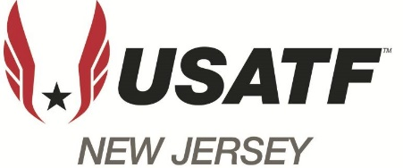
2025
Cross Country
Boys 8-Under
- Bode Bagley Athlete of the Year
- Benjamin Barrett Athlete of the Year
- James Bedara Youth Chair Award
- Ryan Passarotti Youth Chair Award
Girls 8-Under
- Emma Antonelle Athlete of the Year
- Chloe Christophe Youth Chair Award
- Selynah Bilbao-La Vieja Youth Chair Award
Boys 9-10Yr Old- TBD
Girls 9-10 Yr Old-TBD
Boys 11-12 Yr. Old-TBD
Girls 11-12 Yr. Old-TBD

Boys 13-14 Yr. Old-TBD
- Visakan Sathyanarayanan Athlete of the Year
- Andre Fragale Youth Chair Award
- Christopher Blagoev Youth Chair Award
Girls 13-14 Yr. Old
- Molly Cataline Athlete of the Year
- Brielle MacDonald Youth Chair Award
Boys 15-18 Yr. Old
- Edward Letko Athlete of the Year
- Christopher Yue Youth Chair Award
Girls 15-18 Yr. Old
- Emily Lewis Youth Chair Award

