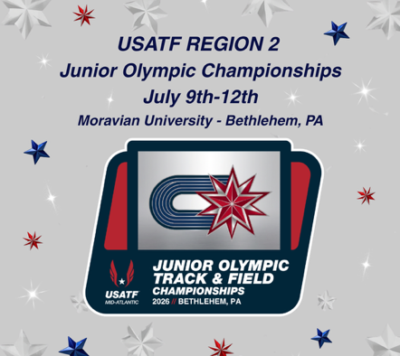

Subject line: Registration Now Open – 2026 USATF Region 2 Junior Olympic Championships

Athletes, Coaches, and Parents,
Registration is now OPEN for the 2026 USATF Region 2 Junior Olympic Championships, to be held July 9–12, 2026, at Moravian University. The Region 2 meet Passport is attached.
Athletic.net R2 registration link: HERE
The Region 2 Championships bring together athletes from the USATF Mid-Atlantic Association, USATF New Jersey Association, USATF Three Rivers Association, and USATF Niagara Association to compete for a chance to advance to the 2026 USATF National Junior Olympic Championships.
Important Registration Dates
- Registration Opened: June 17, 2026
- Registration Deadline: July 4, 2026, at 9:00 PM (ET)
- Late Registration runs: July 4 at 9:01, 2026 PM to July 6, 2026 at 11:59 PM (ET)
- Championship Meet Dates: July 9–12, 2026
We encourage all qualified athletes to register early and review the meet information, schedule, and entry requirements prior to the deadline.
For questions, please reach out to our Race Director Nelson Berrios at: nberriossr@comcast.net
We look forward to welcoming you to Bethlehem for an outstanding weekend of competition.
USATF Region 2 Junior Olympic Championships Organizing Committee

